**Policy Summary for Military Service Members**

**(Voluntary Education Institutional Compliance Program – 2024**

**Tuition Assistance (TA) Program)**

Central Connecticut State University (Central) is pleased to participate in a Voluntary Education Partnership with the United States Department of Defense (DoD). Central ensures compliance with program integrity requirements consistent with the regulations issued by the Department of Defense 2024 Institutional Compliance Program specifically related to restrictions on misrepresentation, recruitment, and payment of incentive compensation to military Service members and/or dependents.

As part of this partnership, Central agrees to follow the Institutional Compliance Program policies and procedures as they relate to Service members eligible for the Tuition Assistance (TA) Program. Please find below important statements, policies, and procedures related to Service members as it relates to recruitment, financial, and enrollment in academic programs.

*An eligible Service member at Central Connecticut State University may be enrolled in the Tuition Assistance (TA) program only after the TA has been approved by the Educational Services Officer (ESO) or counselor within the Military Service (4.d.(1)); in addition, veterans and service members may be eligible to meet with a School Certifying Official about academic programs, application process, supporting services and VA educational benefits prior to enrollment.*

***Central’s Veterans Affairs Meet the Staff Page -*** [*https://www.ccsu.edu/office-veterans-affairs/meet-staff*](https://www.ccsu.edu/office-veterans-affairs/meet-staff)

Sincerely,

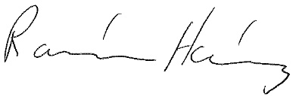

Ramón Hernández

Associate Dean for Student Affairs